A000-Afr-Gabon-Fang-Mask showing Teeth-Early 20th c

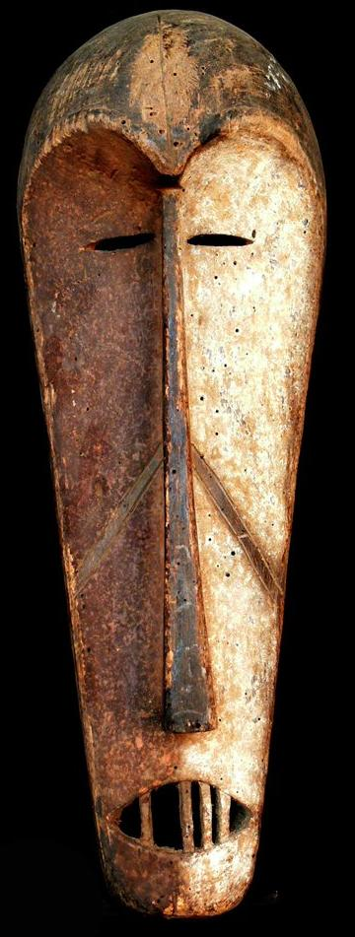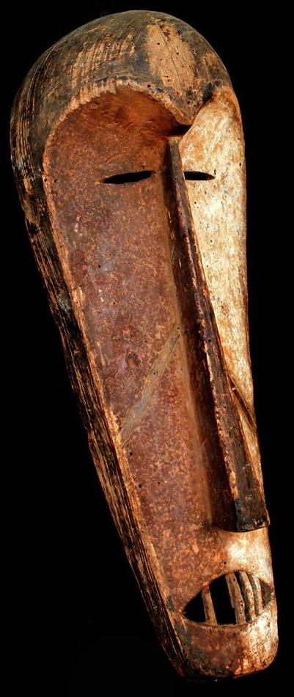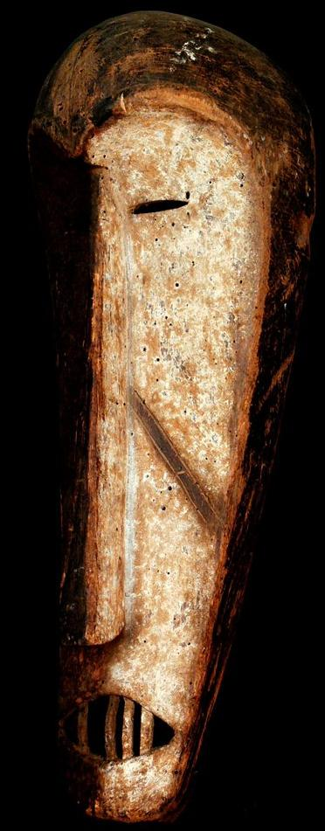

Fang Mask

Origin: Gabon  
Size : 23.22 inches  
Weight : 1.36 pounds  
Material: Wood

Case No.: 6

**Accession No.**

**Formal Label:**

**Display Description:**

**LC Classification:**

**Date or Time Horizon:**

**Geographical Area:**

**Map:**

**GPS coordinates:**

**Cultural Affiliation:**

**Media: wood, kaolin**

**Dimensions:** 23.22 in

**Weight:** 1.36 pounds

**Condition:**

**Provenance:**

**Discussion:**

**References:**

